Youth Programs
MineCraft
Tuesdays 4:00pm - 6:00pm
Junior Sewing Club
Every other Tuesday Beginning
Oct. 15th 5:00pm - 7:00pm
Board Games
Thursdays 4:00pm - 6:00pm
Dungeons & Dragons
Saturdays 12:00pm - 2:00pm
The Artist's Library
Second Saturday of Every Month 12:00pm - 2:00pm
Junior Book Club
Every Second Saturday
11:00am - 12:00pm
Saturday Matinee
Last Saturday of Every Month 11:00am -12:00pm
Lego Club
First Saturday of Every Month
10:00am -11:00am
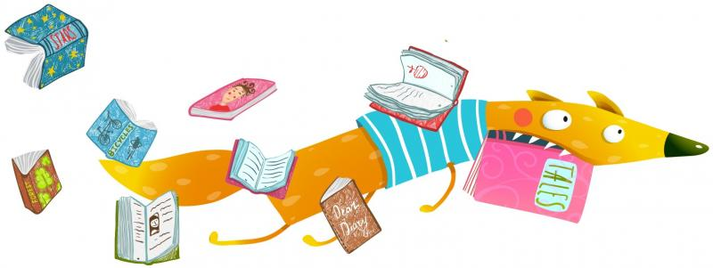
StoryTime
Thursdays 10:30am - 11:30am

